**COMP2432 – Project Demonstration**

|  |  |  |  |
| --- | --- | --- | --- |
| **Group No: G05** |  |  |  |
| **Members:**  DENG Chun Yung (21084115D)  JIANG Guanlin (21093962D)  LI Tong (21101988D)  LIU Yuzhou (21100602D)  NIYITEGEKA Berwa Aime Noel (21104645D) |  |  |  |

Rename this file to begin with your Group Number, e.g. G88_Demo_Task.docx. After the demonstration, you are asked to submit this file to the Blackboard before the deadline. In addition, please take a **video** to record and complete the following tasks:

**Task 1:**

Compile your source code file(s) and start the application with the following instruction.

./apo 20230501 20230531 amada billy cathy danny emily

Capture the screen and paste it in the box below.

*Paste the screen shot here.*

Exit the program.

**Task 2:**

Restart your application as what have done in Task 1 and do the following:

2.1 Add the following appointment requests:

* privateTime billy 20230502 1900 3.0
* groupStudy cathy 20230505 1800 4.0 danny emily
* privateTime amada 20230515 2000 3.0
* gathering danny 20230511 1800 5.0 amada billy cathy emily
* groupStudy emily 20230516 2000 3.0 amada billy

2.2 Execute the “**printSchd ALL**” command to print out Schedules with the algorithm(s) which you have implemented in your application.

Capture the screen(s) and insert the picture(s) below.

*Paste the screen shot here.*

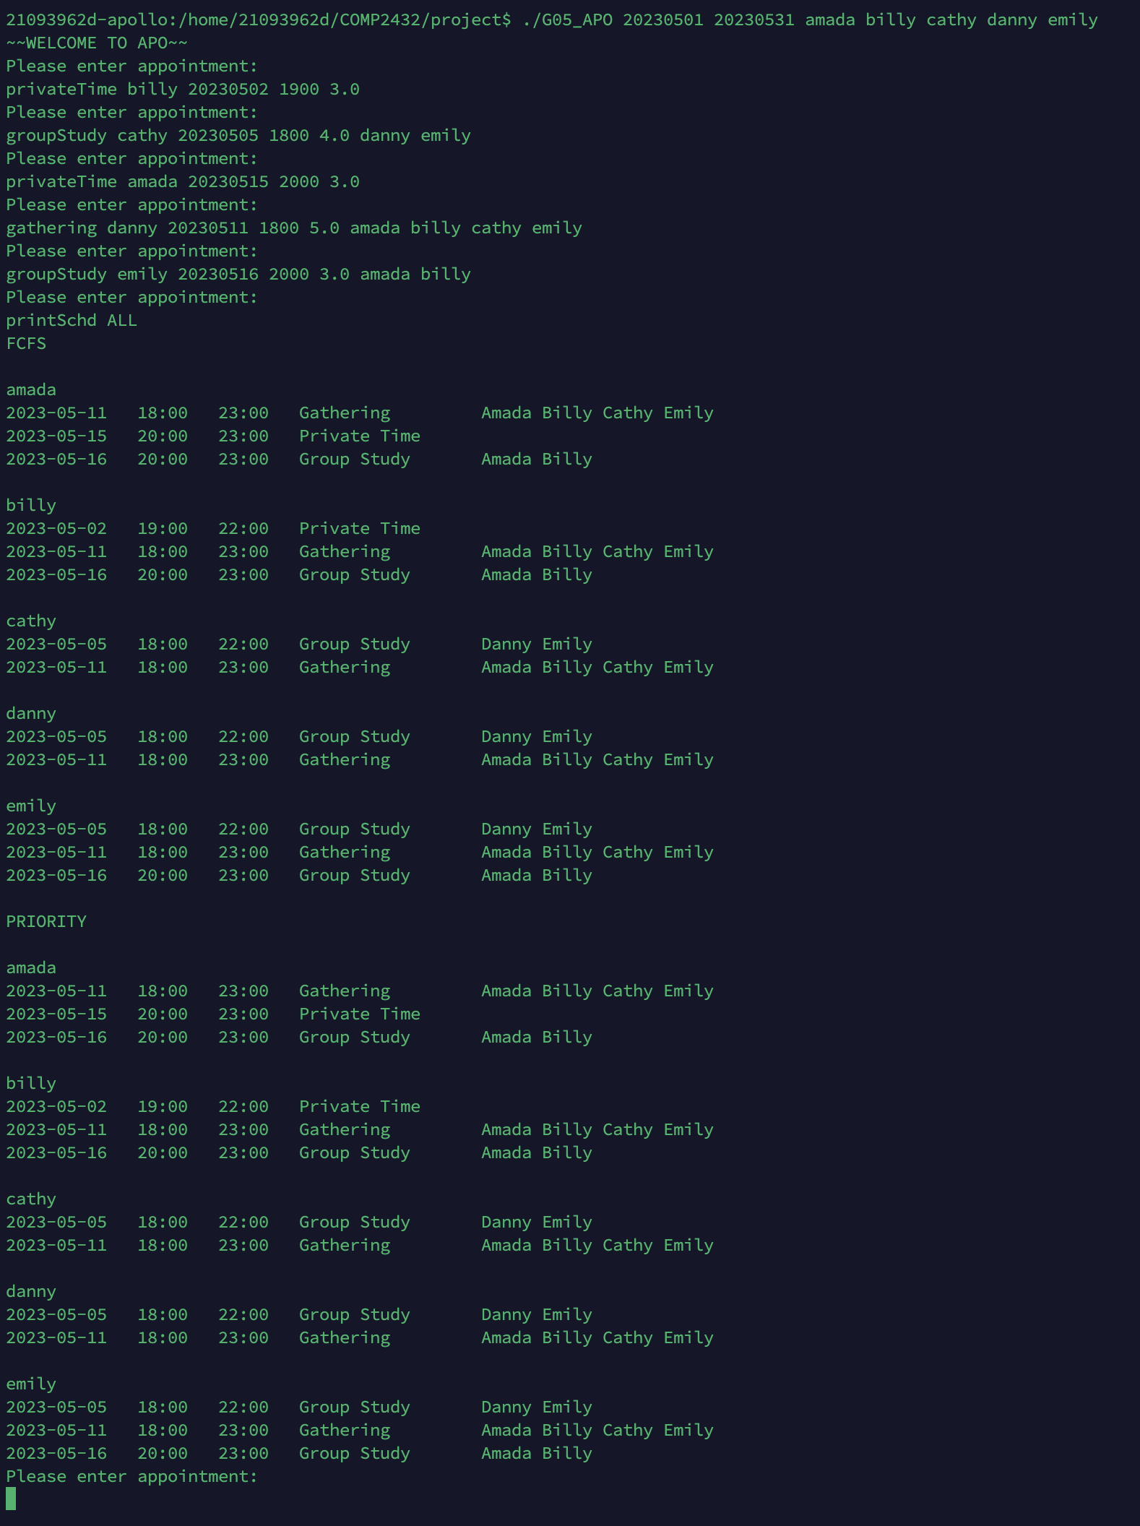

*Paste the screen shot here.*

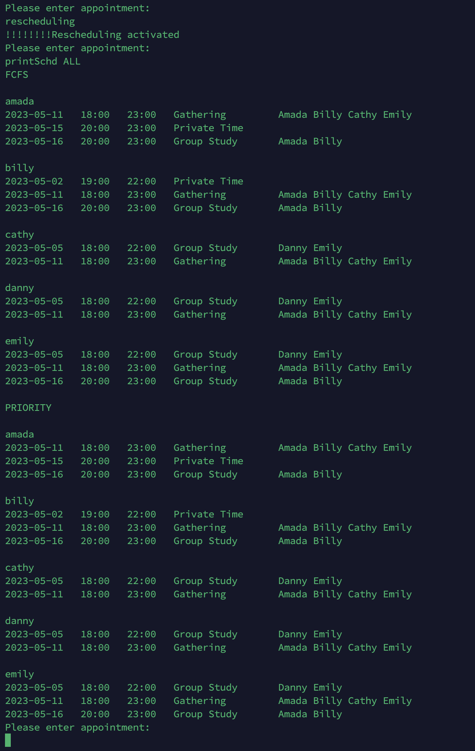

If you have done the "**bonus**" part, simply show us the operation and capture appropriate screens and paste the pictures in this document.

**\*\*\* Do not exit. \*\*\***

**\*\*\* Keep running your application to do the following tasks. \*\*\***

**Task 3:**

Import the batch file, demo_data01.dat and generate reports as what you have done in Task 2.2.

Capture the screen and insert the picture below.

*Paste the screen shot here.*

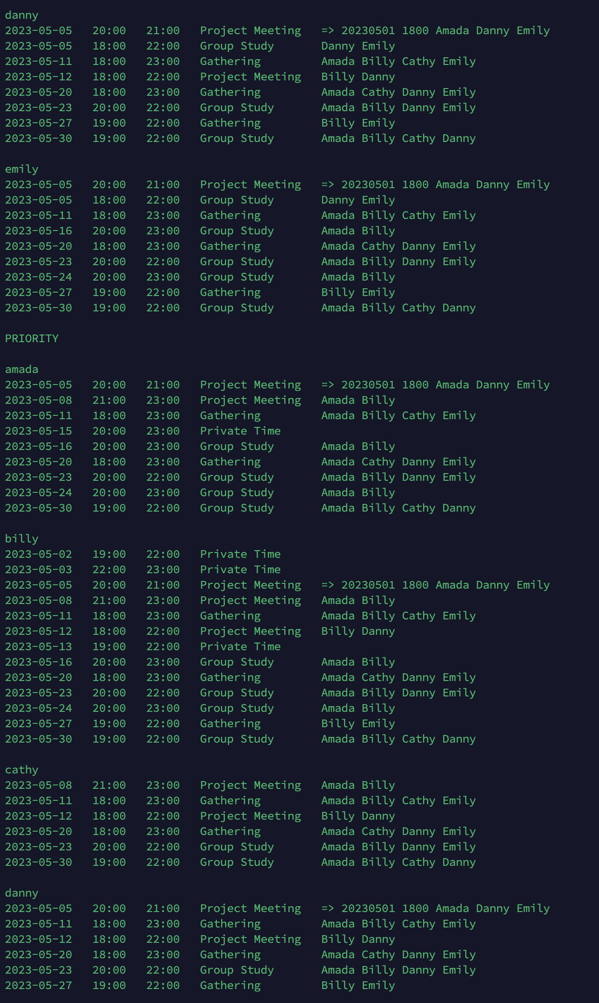

***Again, don’t terminate your program***

**Task 4:**

Import another batch file, demo_data02.dat and generate reports as what you have done in Task 2.2.

Capture the screen and insert the picture below.

*Paste the screen shot here.*

*…. (too many)*

**Task 5:**

Demonstrate how your application handles request which involves “public holiday” or “Sunday”.

Capture the screen and insert the picture below.

*Paste the screen shot here.*

*No public holiday and Sunday in here.*

You may now terminate your application and stop the video recording.

**Task 6:**

Create a folder and name it with your **Group Number.** Put all those output files (generated during the demo) under this folder and include this Word document file. Then, zip the folder and upload the **zipped file** to the Blackboard.

If you have revised your source code, you need to include the revised source code file in the zip file.

Again, if the size of the video file is too large and has problem to upload to the Blackboard, send us a link to download it.

***** End of Demo *****

Good Luck!